Installation Instructions

1. **Install Database**
2. Run **QuanLyNhaHang.sql** script in **Database folder**. You should use the **MySQL workbench** to run script.

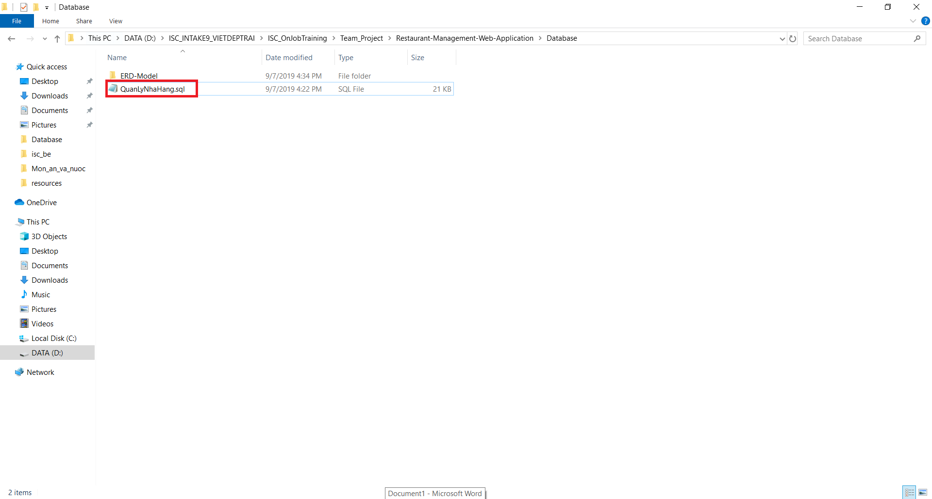

* 1. Database Script

1. **Install Spring Tool Suite 4 for Eclipse**
2. We have to install STS 4 to run back-end. After Installing STS 4 we open it and choose Workspace for it. Workspace is the **Back-end folder**. Then we click launch.

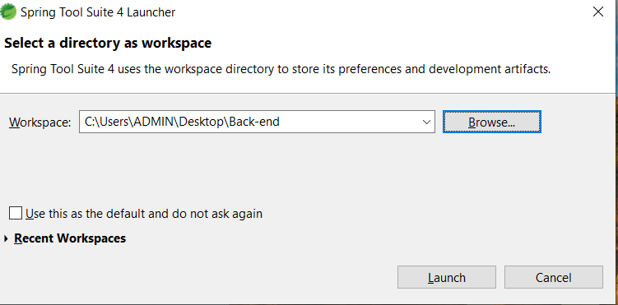

* 1. Choose Workspace

1. We choose **Import projects**

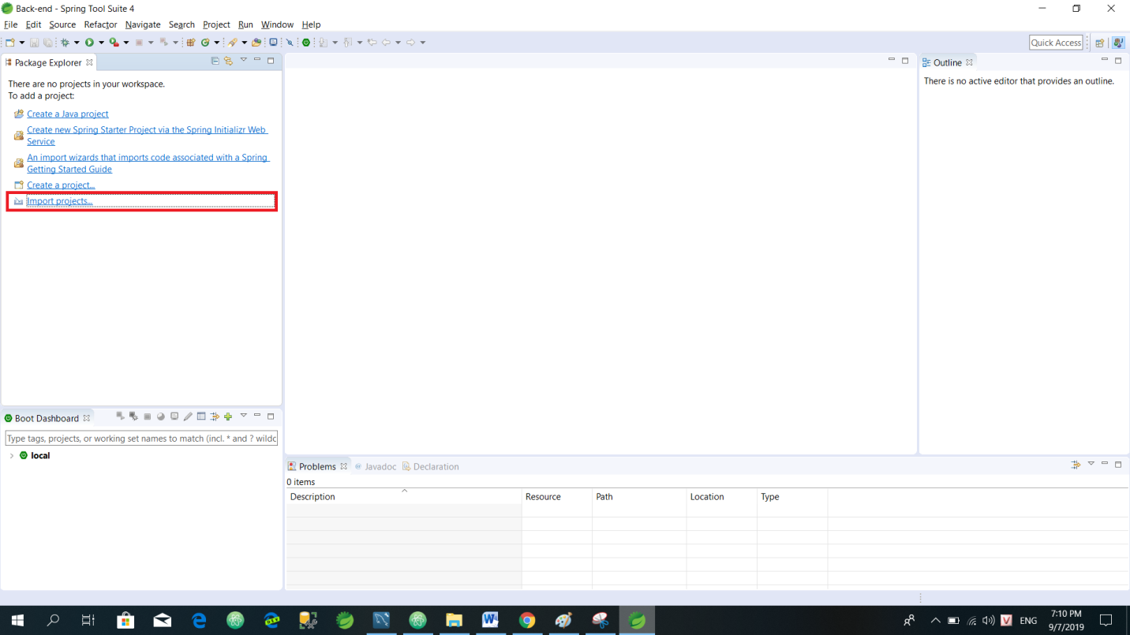

* 1. Import Projects

1. We click **Maven**, choose **Existing Maven Projects** and click **Next**

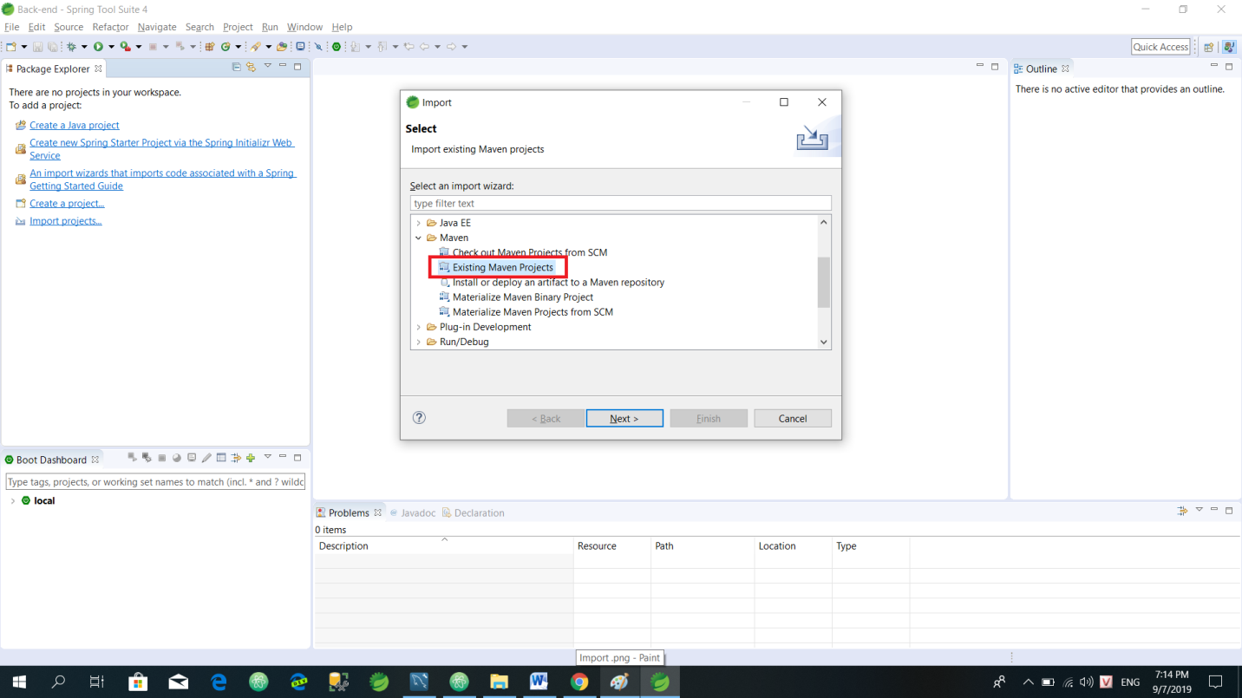

* 1. Choose Maven Projects

1. We click Browse… to choose **Root Directory**. **Root Directory** is the **QuanLyNhaHang** folder. Then we click **Finish**

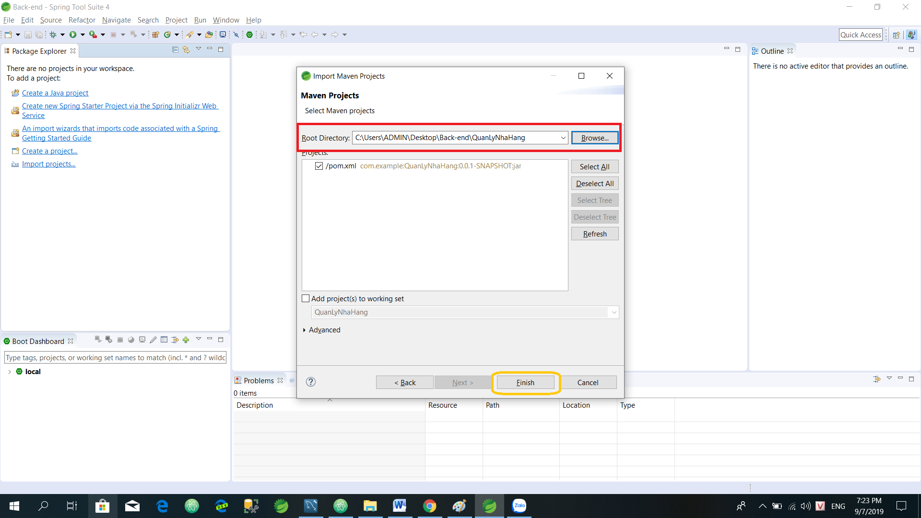

* 1. Choose Root Directory

1. After we choose **Root Directory,** we need to wait for it to import the libraries. Maybe it will happen within a few minutes
2. Then we click **src/main/resources** and choose **application.properties**.

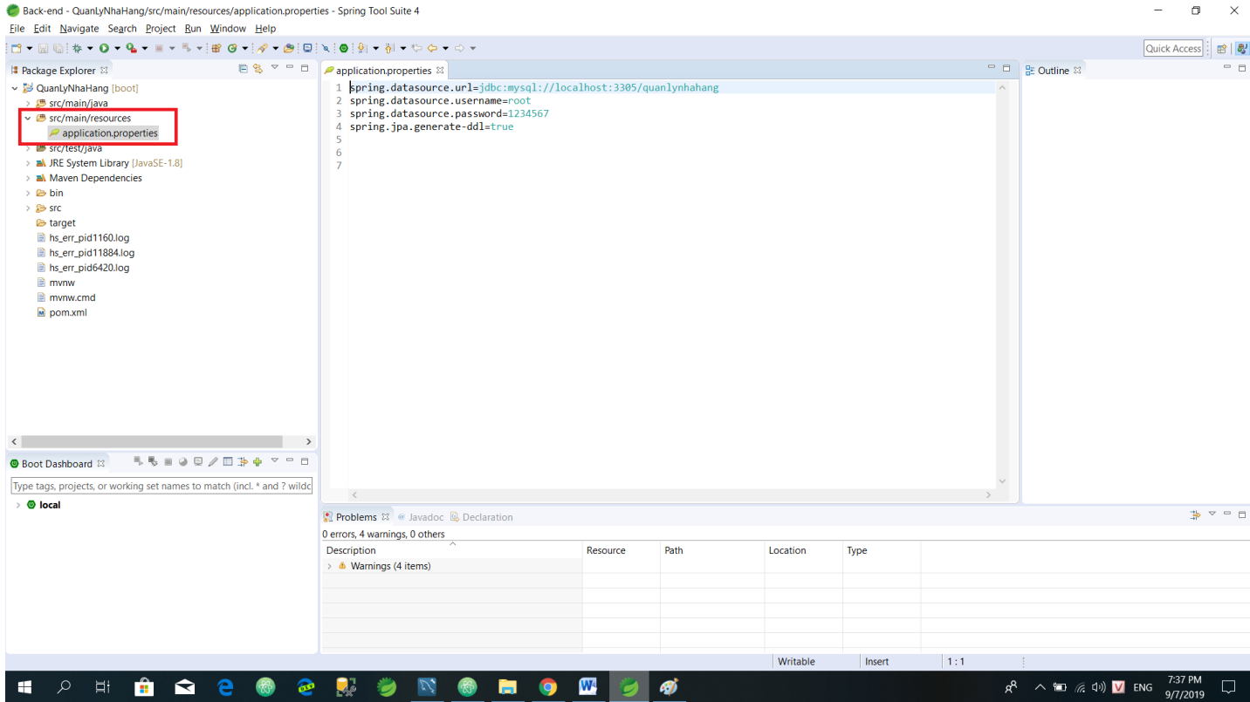

* 1. Choose application.properties

1. We config info to connect database. Here we use MySQL DB, so we have to config info to match our MySQL info

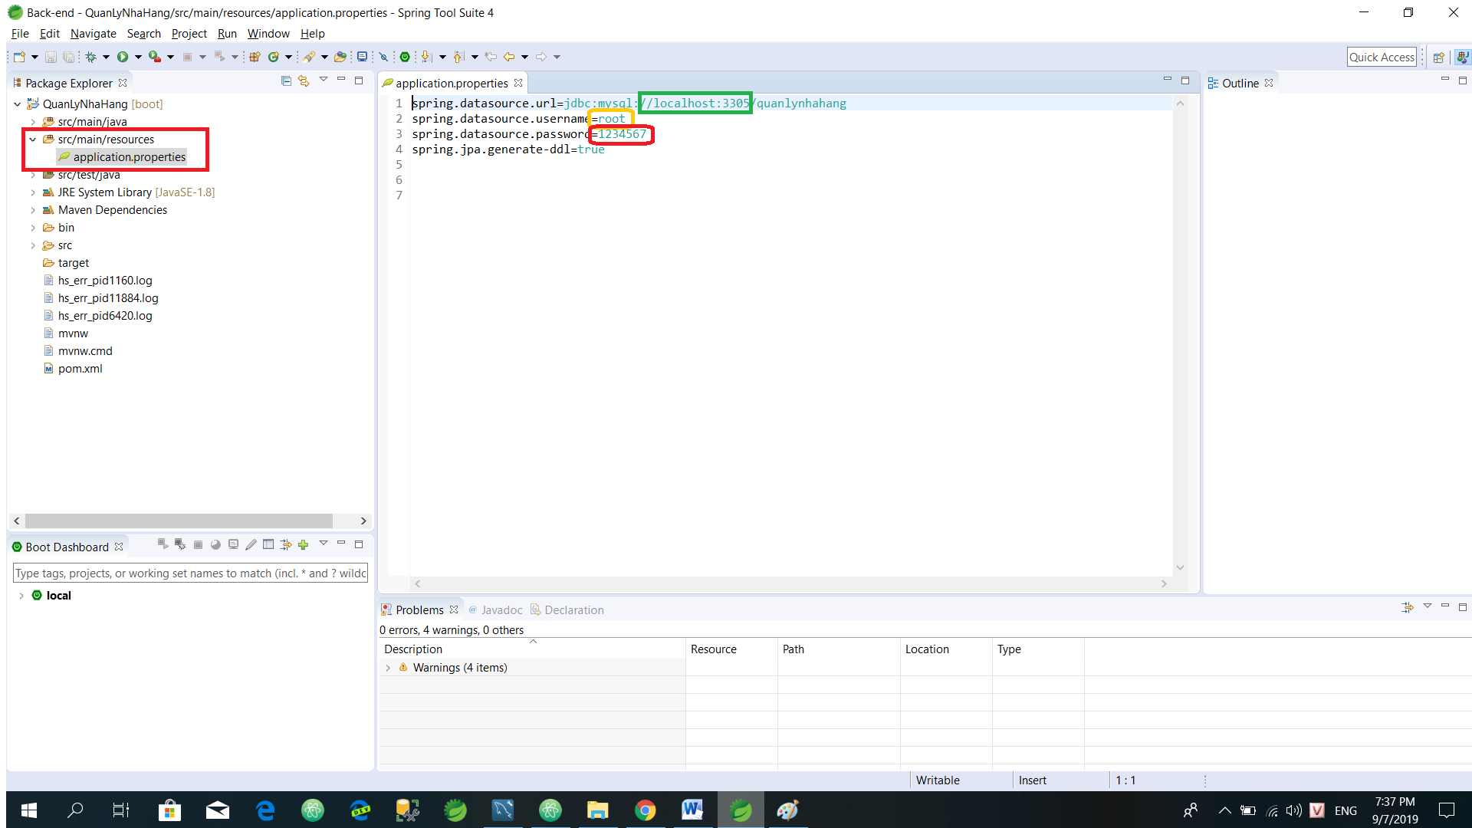

* 1. Config info to connect DB

1. We click **QuanLyNhaHang [boot]**, choose **Run As** and choose **Spring Boot App** to run **server**

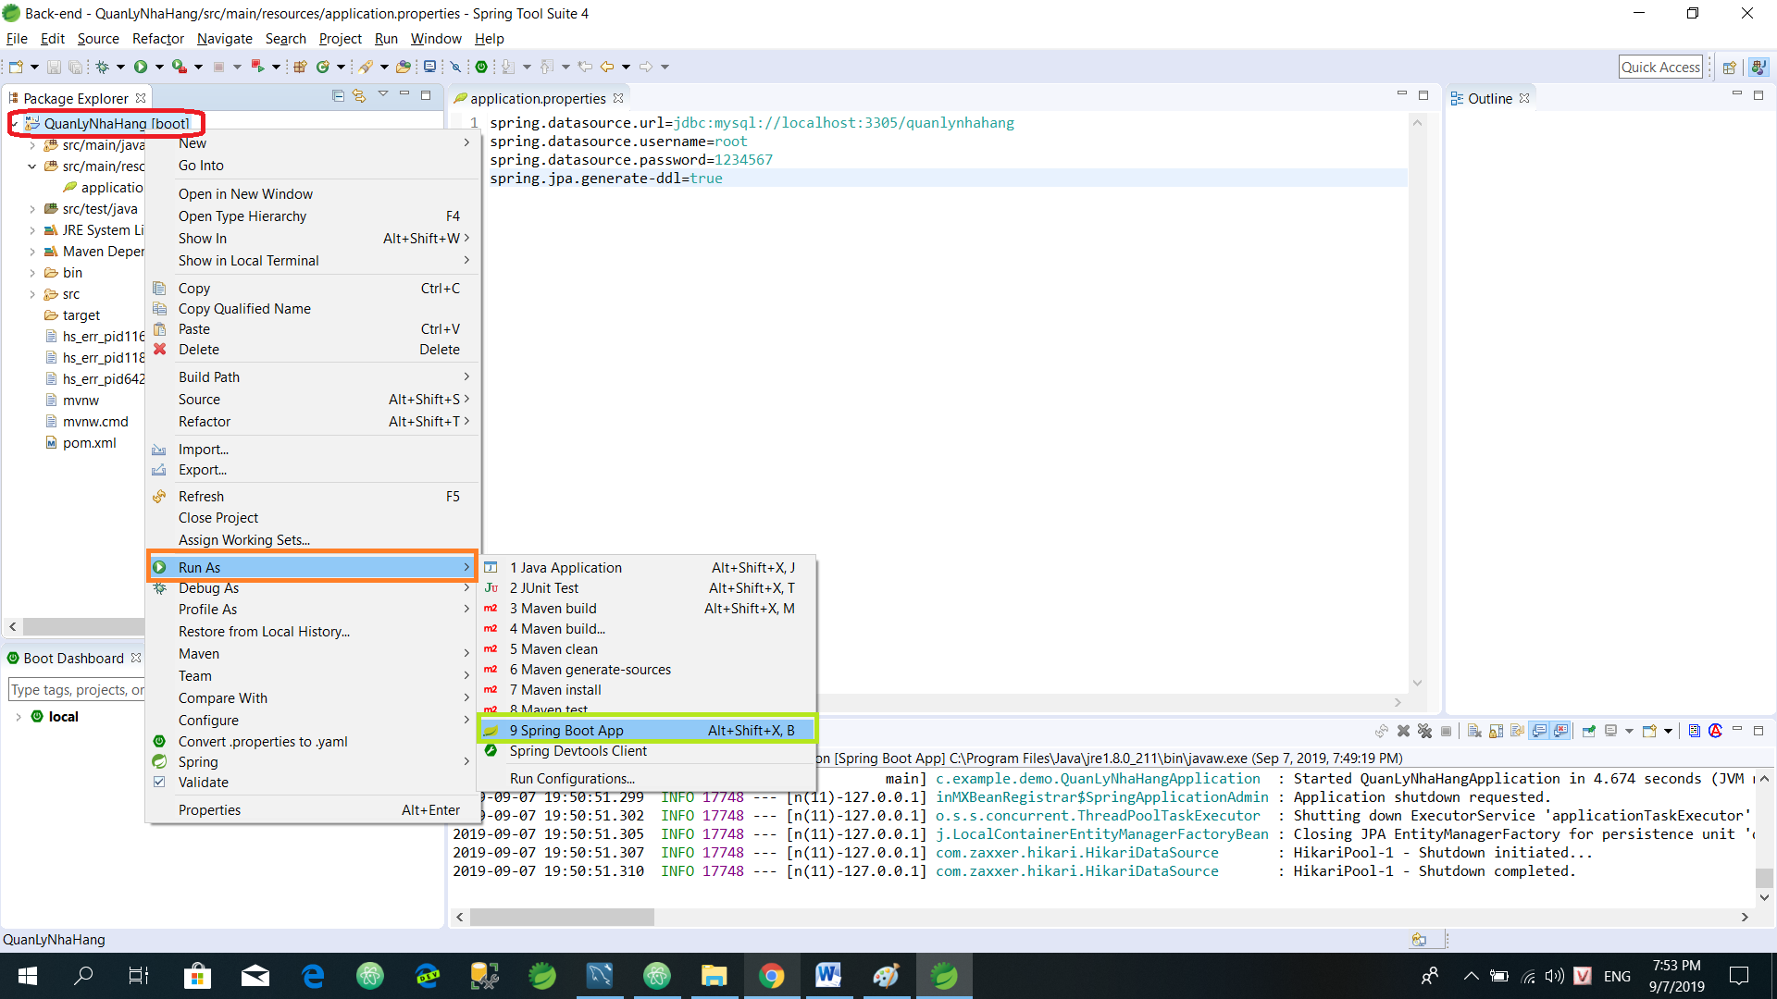

2.7 Run server

If it runs successfully, it will display a message like the image below

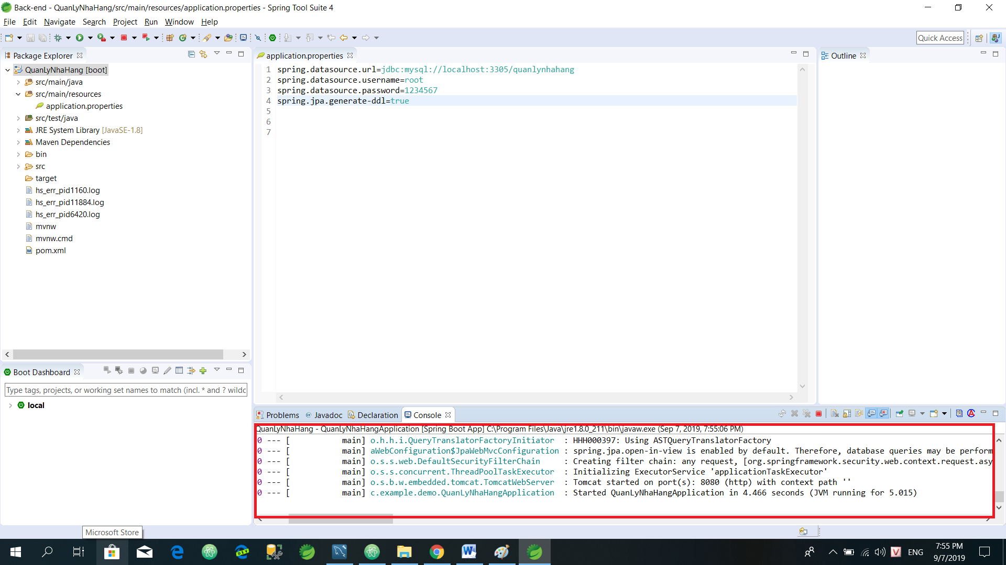

* 1. Run server successfully

1. **Install IDE to run front-end (Atom, VSCode…)**
2. Here I use **Atom** IDE to run **front-end** folder. You can install Atomto run it, same me. After you install Atom, you have to install **atom-live-server plugin** to run ***front-end on server (It is essential)***.

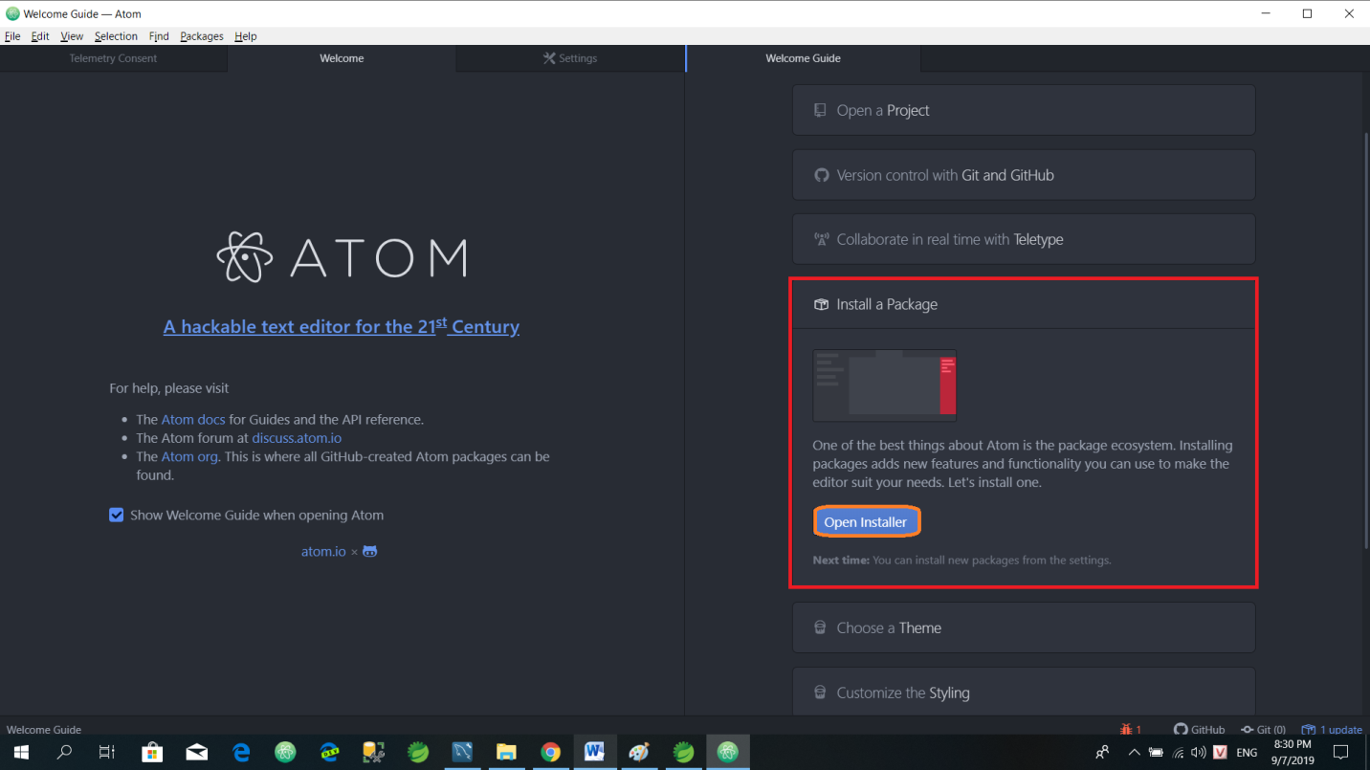

* 1. Install atom-live-server

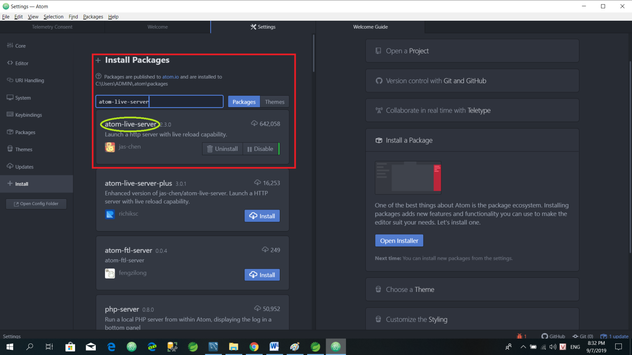

* 1. Install atom-live-server

1. After we install **atom** and **atom-live-server**, we can run front-end folder on server. We click **Add Project Folder and choose front-end folder** 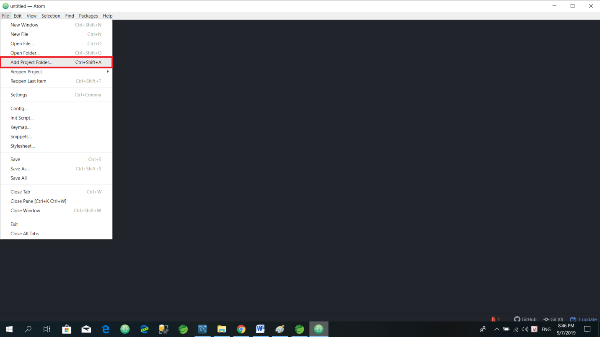
   1. Add Project Folder

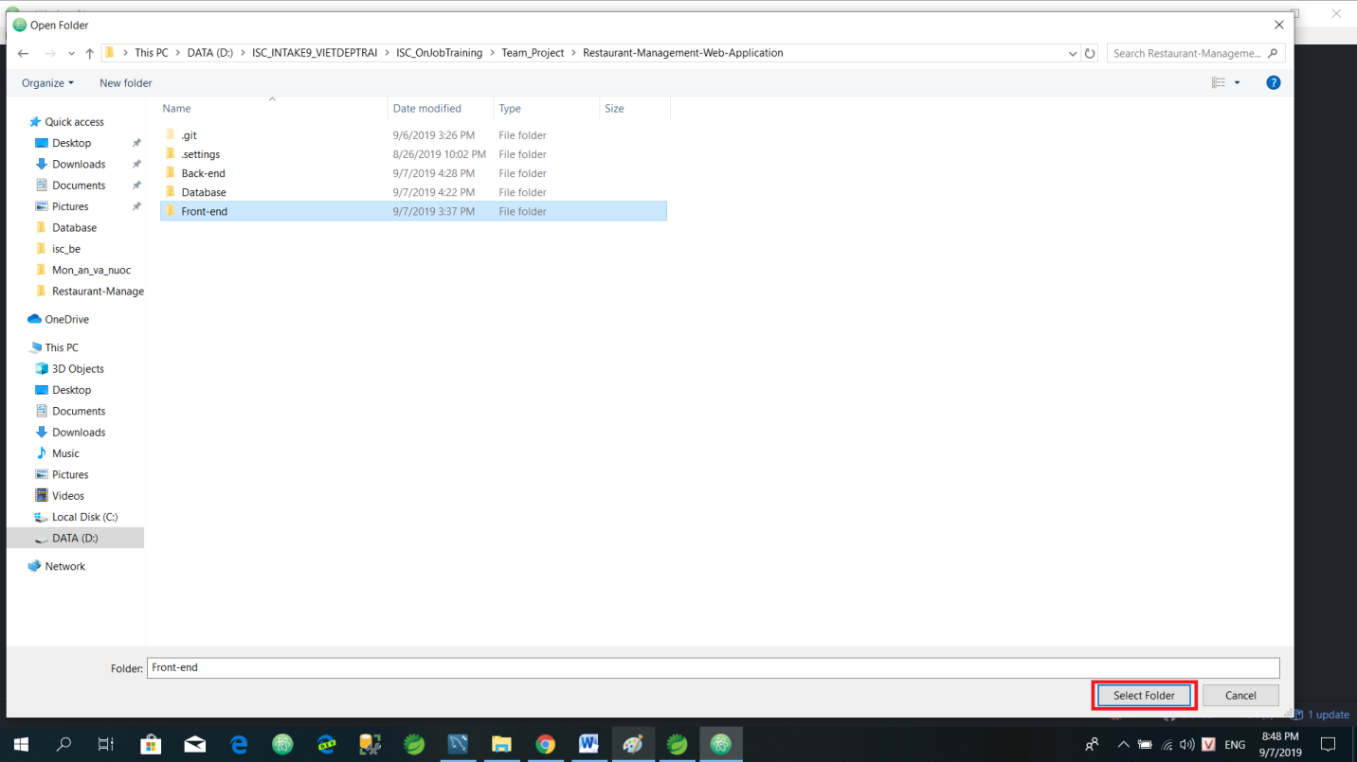

* 1. Select Front-end folder

1. Then, we click **Packages**, choose **atom-live-server** and click **Start server** to run front-end on server

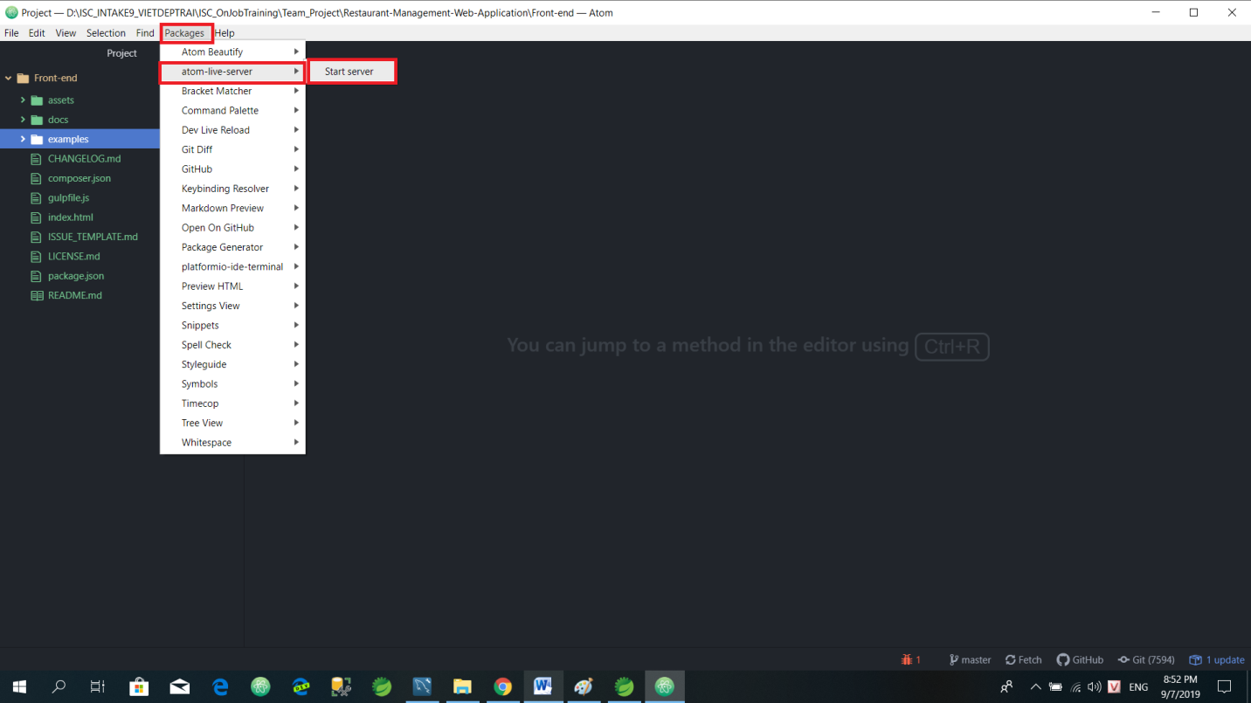

* 1. Run front-end on Server

If it runs successfully, it will show website like the image below

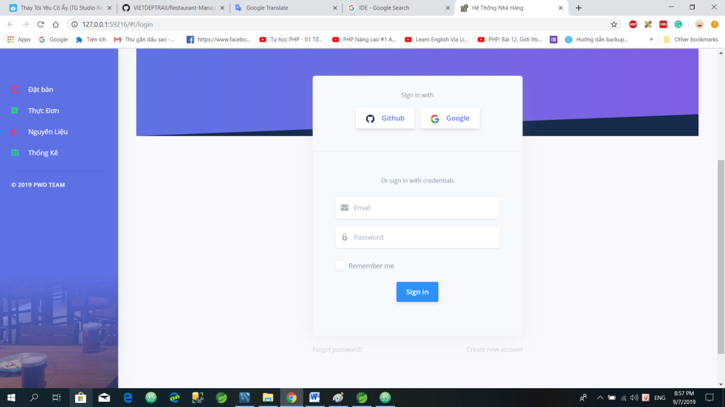

* 1. Run front-end on server successfully

1. Final, you need to login and enjoy it ☺

* **Email:** [**admin@gmail.com**](mailto:admin@gmail.com)
* **Password:** 1234567